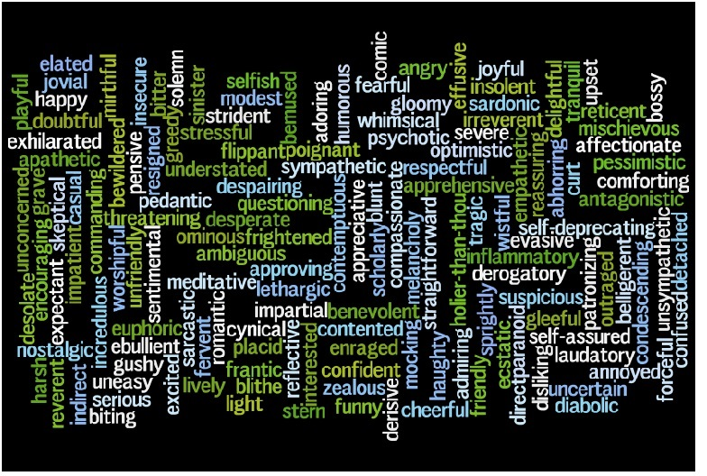

Mood
Mood is the atmosphere of a piece of writing; it’s the emotions a selection arouses in a reader.
Some common mood descriptors are:
POSITIVE MOOD WORDS |  | NEGATIVE MOOD WORDS
amused  awed  bouncy  calm  cheerful  chipper  confident  contemplative  content  determined  dignified  dreamy  ecstatic  empowered  energetic  enlightened  enthralled  excited  exhilarated  flirty  giddy  grateful  harmonious  hopeful  hyper  idyllic  joyous | jubilant  liberating  light-hearted  loving  mellow  nostalgic  optimistic  passionate  peaceful  playful  pleased  refreshed  rejuvenated  relaxed  relieved  satiated  satisfied  sentimental  silly  surprised  sympathetic  thankful  thoughtful  touched  trustful  vivacious  warm  welcoming | aggravated  annoyed  anxious  apathetic  apprehensive  barren  brooding  cold  confining  confused  cranky  crushed  cynical  depressed  desolate  disappointed  discontented  distressed  drained  dreary  embarrassed  enraged  envious  exhausted  fatalistic  foreboding  frustrated  futile  gloomy  grumpy  haunting  heartbroken  hopeless  hostile  indifferent  infuriated | insidious  intimidated  irate  irritated  jealous  lethargic  lonely  melancholic  merciless  moody  morose  nauseated  nervous  nightmarish  numb  overwhelmed  painful  pensive  pessimistic  predatory  rejected  restless  scared  serious  sick  somber  stressed  suspenseful  tense  terrifying  threatening  uncomfortable  vengeful  violent  worried
One good way to see mood (and, to a degree, tone) in action is through genre-crossing movie trailers. In film editing classes throughout the States, a common assignment is to take an existing film (say, a comedy) and create a film preview that presents the film as a different genre (for example, a horror film). This is accomplished through editing and splicing scenes, adding new, anxiety-producing music and sound effects, and adding a new voice-over introduction.
Some of the best examples of this are below.
- Mary Poppins as a horror film: Scary Mary
- Dumb and Dumber was turned into a horror film, Lurk and Lurker: Dumb and Dumber (Horror)
- The Shining was transformed from horror film into a feel-good romantic comedy: The Shining (Feel-Good/Romantic Comedy)

